

**Asset Practice Questions: Mathematics**

1. On 5 th June, World Environment Day, five children planted saplings in a garden near their school. The number of saplings that each of them planted is shown in the pictograph:

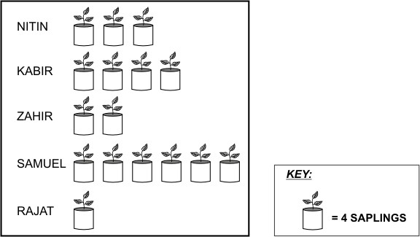

What is the total number of saplings planted by the five children?

A. 16

B. 20

C. 32

D. 64

2. Prabhu is using his broken scale to measure the length of a chalk stick.

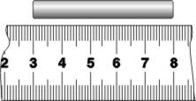

What is the length of the chalk stick? A. 5 cm

B. 6 cm

C. 8 cm

D. He cannot find out the length as the scale is broken.

3. Ekta bought a ribbon as shown here.

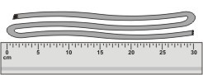

The ribbon is around

A. 10 cm long.

B. 30 cm long.

C. 90 cm long.

D. We can't say. We need a longer scale to measure it.

4. The costs of 3 different chocolate bars are shown in this table.

|  |  |
| --- | --- |
| **CHOCOLATE** | **COST PER BAR** |
| CRUNCH BAR | Rs. 11 |
| FRUIT BAR | Rs. 13 |
| NUT BAR | Rs. 22 |

Lata bought 4 NUT bars.For the same amount of money, how many CRUNCH bars could she have

bought?

A. 11

B. 8

C. 4

D. 2'

5. Sheel counted the number of flowers in her garden. She made the following chart.

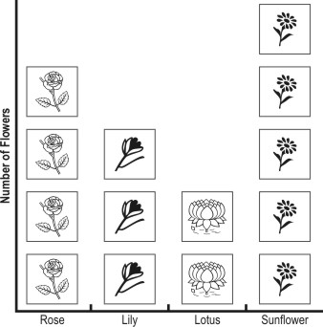

Sheel's mother asked her to bring 3 flowers from the garden. She told Sheel that it could be any flower but all 3 flowers must be of the same type. Which flowers can Sheel bring?

A. only lily

B. only lotus

C. either lily or rose

D. any of lily, rose or sunflower

6. Given below is a list of TV programs that Romy would like to watch on a day.

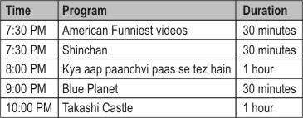

Romy is allowed to watch TV for AT MOST 1 HOUR (all programs together). He wants to watch 2 programs. Which two programs can he watch completely?

A. Shinchan and Blue Planet

B. Shinchan and Kya aap paanchvi paas se tez hain

C. Blue Planet and Takashi Castle

D. American Funniest videos and Takashi Castle

7. This is the score-card of a recent India-Sri Lanka One Day International cricket match. Study it carefully and answer the question that follows.

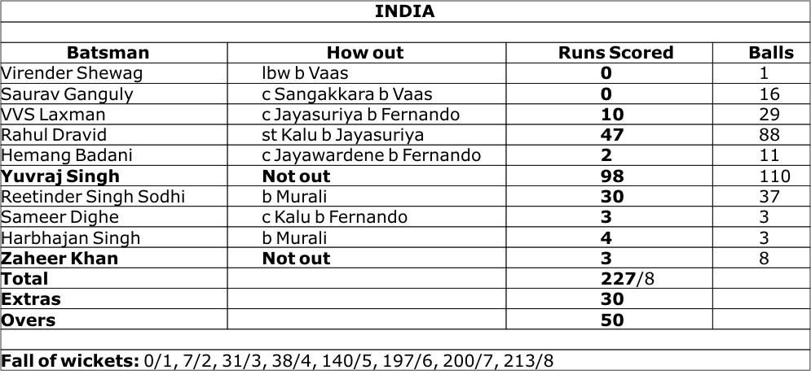

The total runs scored by the first 5 batsmen was:

A. 49

B. 59

C. 57

D. 145

8. A number is missing in the addition problem below.

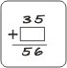

What will you do to find the missing number in the  ?

A. 35 + 56

B. 56 - 35

C. 56 + 35

D. 35 - 56

9. A number is subtracted from 264. The answer is LESS THAN 100.

Which of these could be the number?

A. 83

B. 160

C. 164

**D. 177**

10. 500 - 46 gives the same answer as 400 + ?

A. 46

**B. 54**

C. 64

D. 146

11. 220 + 380 = + 400 What should come in the blank above to make the number sentence true?

**A. 200**

B. 380

C. 600

D. 1000

12. Which of the following would give the same answer as 18 - 5?

A. 13 + 5

**B. 21 - 8**

C. 18 - 3

D. 21 - 3